# 

# LAB 10

# COLLECTION - LIST

EXERCISE 1

Given an ArrayList, the task is to get the first and last element of the ArrayList in Java.

Input: ArrayList = [1, 2, 3, 4]

Output: First = 1, Last = 4

Input: ArrayList = [12, 23, 34, 45, 57, 67, 89]

Output: First = 12, Last = 89

Approach:

1. Get the ArrayList with elements.
2. Get the first element of ArrayList using the get(index) method by passing index = 0.
3. Get the last element of ArrayList using the get(index) method by passing index = size – 1

Answer:

//Arraylist

import java.util.*;

public class main

{

public static void main(String[] args)

{

Scanner obj=new Scanner(System.in);

int n=obj.nextInt();

ArrayList<Integer> list=new ArrayList<>();

for(int i=0;i<n;i++)

{

list.add(obj.nextInt());

}

System.out.println("ArrayList: "+list);

System.out.println("First : "+list.get(0)+", "+"Last : "+list.get(n-1));

obj.close();

}

}

|  | **Test** | **Input** | **Expected** | **Got** |  |
| --- | --- | --- | --- | --- | --- |
|  | 1 | 6  30  20  40  50  10  80 | ArrayList: [30, 20, 40, 50, 10, 80]  First : 30, Last : 80 | ArrayList: [30, 20, 40, 50, 10, 80]  First : 30, Last : 80 |  |
|  | 2 | 4  5  15  25  35 | ArrayList: [5, 15, 25, 35]  First : 5, Last : 35 | ArrayList: [5, 15, 25, 35]  First : 5, Last : 35 |  |

EXERCISE 2

The given Java program is based on the ArrayList methods and its usage. The Java program is partially filled. Your task is to fill in the incomplete statements to get the desired output.

list.set();

list.indexOf());

list.lastIndexOf())

list.contains()

list.size());

list.add();

list.remove();

The above methods are used for the below Java program.

Answer:

import java.util.ArrayList;

import java.util.Scanner;

public class Prog {

public static void main(String[] args)

{

Scanner sc= new Scanner(System.in);

int n = sc.nextInt();

ArrayList<Integer> list = new ArrayList<Integer>();

for(int i = 0; i<n;i++)

list.add(sc.nextInt());

// printing initial value ArrayList

System.out.println("ArrayList: " + list);

//Replacing the element at index 1 with 100

list.set(1,100);

//Getting the index of first occurrence of 100

System.out.println("Index of 100 = "+ list.indexOf(100) );

//Getting the index of last occurrence of 100

System.out.println("LastIndex of 100 = "+ list.lastIndexOf(100) );

// Check whether 200 is in the list or not

System.out.println( list.contains(200) ); //Output : false

// Print ArrayList size

System.out.println("Size Of ArrayList = "+ list.size() );

//Inserting 500 at index 1

list.add(1,500) ; // code here

//Removing an element from position 3

list.remove(list.get(3)); // code here

System.out.print("ArrayList: " + list);

}

}

|  | **Test** | **Input** | **Expected** | **Got** |  |
| --- | --- | --- | --- | --- | --- |
|  | 1 | 5  1  2  3  100  5 | ArrayList: [1, 2, 3, 100, 5]  Index of 100 = 1  LastIndex of 100 = 3  false  Size Of ArrayList = 5  ArrayList: [1, 500, 100, 100, 5] | ArrayList: [1, 2, 3, 100, 5]  Index of 100 = 1  LastIndex of 100 = 3  false  Size Of ArrayList = 5  ArrayList: [1, 500, 100, 100, 5] |  |

EXERCISE 3

Write a Java program to reverse elements in an array list.

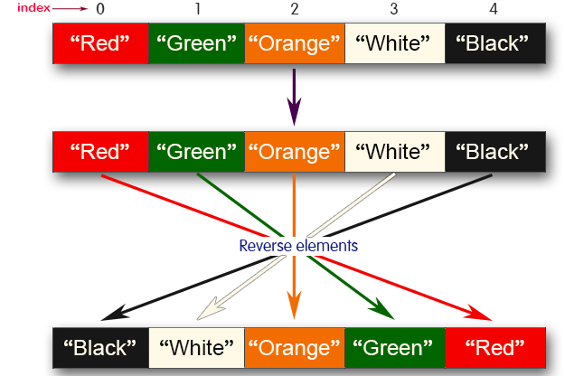

Sample input and Output:

Red

Green

Orange

White

Black

Sample output

List before reversing :

[Red, Green, Orange, White, Black]

List after reversing :

[Black, White, Orange, Green, Red]

Answer:

//Reverse in arraylist

import java.util.*;

public class Main

{

public static void main(String[] args)

{

Scanner obj=new Scanner(System.in);

int n=obj.nextInt();

ArrayList<String> list=new ArrayList<>();

for(int i=0;i<n;i++)

{

list.add(obj.next());

}

System.out.println("List before reversing :"+"\n"+list);

Collections.reverse(list);

System.out.println("List after reversing :"+"\n"+list);

obj.close();

}

}

|  | **Test** | **Input** | **Expected** | **Got** |  |
| --- | --- | --- | --- | --- | --- |
|  | 1 | 5  Red  Green  Orange  White  Black | List before reversing :  [Red, Green, Orange, White, Black]  List after reversing :  [Black, White, Orange, Green, Red] | List before reversing :  [Red, Green, Orange, White, Black]  List after reversing :  [Black, White, Orange, Green, Red] |  |
|  | 2 | 4  CSE  AIML  AIDS  CYBER | List before reversing :  [CSE, AIML, AIDS, CYBER]  List after reversing :  [CYBER, AIDS, AIML, CSE] | List before reversing :  [CSE, AIML, AIDS, CYBER]  List after reversing :  [CYBER, AIDS, AIML, CSE] |  |